Natural Language Processing - Final Project
  - Transformer-Based Sentiment Classification
Group: 10 - Falgun Parikh and Jonathan Chacko Pattasseril

1. Introduction
Sentiment analysis is a central sub-discipline of Natural Language Processing (NLP) that attempts to label documents with either positive, negative or neutral sentiment. The current work examines the topic of binary sentiment classification of the customers reviews of the IMDb Movie Reviews Dataset. The paper fine-tunes the pre-trained Transformer model BERT and reports its performance as compared to traditional machine-learning baselines (Logistic Regression, support-vector machines ( SVM ), naive Bayes, and random forest ) along with TF-IDF-encoded features.
Our goal is to evaluate:
- Whether a Transformer-based model performs better than classic ML baselines.
- The confusion matrices, quantitative and qualitative behavior of the models using metrics and error analysis.

2. Dataset & Preprocessing
Data set: IMDb Movie Reviews 50,000 of the posts tagged as the positive or the negative review.

Preprocessing Steps:
- Lowercasing text
- Removing HTML tags and punctuation
- Tokenization
- Preprocessing of transformers (WordPiece tokenization, special tokens [CLS], [SEP])
- Padding and truncation to a fixed length
- TF-IDF vectorization (max features = 5000) usage as baselines

Data Split:
- Train: 40,000 reviews
- Validation: 5,000 reviews
- Test: 5,000 reviews

3. Model Architectures

3.1 Transformer-Based Model (BERT)
- Base Model: BERT-base-uncased
- Fine-Tuning: This is followed by binary output Extra head of classification (Dense layer)
- Optimizer: AdamW
- Loss Function: Cross-entropy
- Epochs: 3
- Batch Size: 16
- Evaluation Metrics: Accuracy, Precision, Recall, F1-score

3.2 Baseline Models
Using TF-IDF vectorization, trained:
- Logistic Regression
- Support Vector Machine (SVM)
- Multinomial Naive Bayes
- Random Forest

4. Results & Evaluation

4.1 Transformer (BERT) Performance:
Epoch | Train Loss | Val Loss | Val Acc | Precision | Recall | F1
1 | 0.2747 | 0.2781 | 0.8874 | 0.8416 | 0.9544 | 0.8945
2 | 0.1779 | 0.3077 | 0.8988 | 0.8966 | 0.9016 | 0.8991
3 | 0.1110 | 0.4269 | 0.8992 | 0.8871 | 0.9148 | 0.9007
Test Set Results:
- Accuracy: 0.889
- Precision: 0.8469
- Recall: 0.9496
- F1-score: 0.8953

4.2 Baseline Model Performance (Test Set)
Model | Accuracy | Precision | Recall | F1
Logistic Regression | 0.8914 | 0.8919 | 0.8908 | 0.8913
SVM | 0.8856 | 0.8900 | 0.8800 | 0.8850
Naive Bayes | 0.8516 | 0.8505 | 0.8532 | 0.8518
Random Forest | 0.8414 | 0.8505 | 0.8284 | 0.8393

5. Visualizations
Figure 1: Training and Validation Loss over epochs of BERT model.
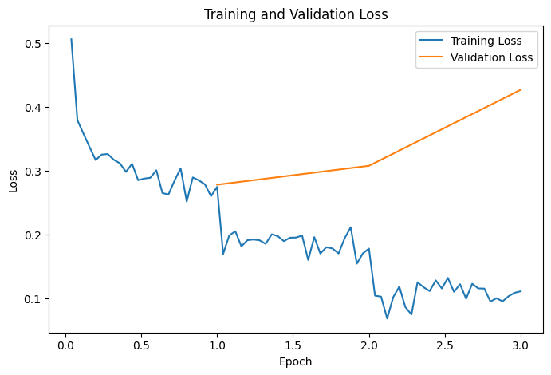
Loss Curves: Loss lessened with training but amplified with validation past epoch 2, which means that there is slight overfitting.
- The loss on the training set is gradually decreasing and the validation loss starts growing after epoch 2 indicating starting of overfitting.
- The trend indicates why it is important to apply early stopping/regularization to achieve better generalization.

Figure 2: Validation Accuracy on every epoch on BERT model.
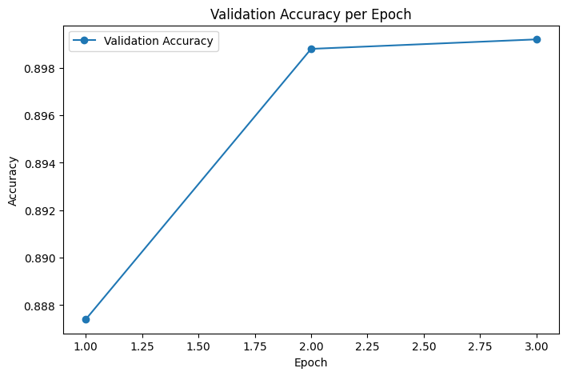
Accuracy Curve: Validation accuracy plateaued after epoch 2.
- The correctness of validation is increasing significantly between the first and the second and not reaching a steady state in the third.
- It implies the primary facet of learning took place in the early phases of the process of training and additional epochs cannot cause significant upgrading.

6. Error Analysis
Figure 3: Confusion Matrix for the BERT model on the test set.
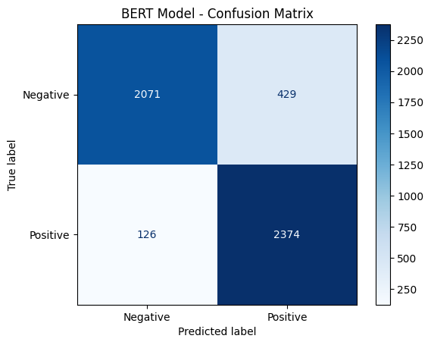
The model's classification performance, as reflected by the confusion matrix, reveals a generally balanced distinction between false positives (429) and false negatives (126), indicating that the model occasionally misinterprets negative reviews as positive and vice versa. The counts of true positives (2,374) and true negatives (2,071) further suggest solid predictive ability, though challenges remain. Many false positives arise when the model encounters snarky or subtly critical writing, leading to an overestimation of positivity. Conversely, false negatives often occur in reviews with ambiguous sentiment—such as those using sarcasm, joined or mixed emotions, or where strongly negative language is paired with overall neutral or even positive ratings. These errors highlight the nuanced and sometimes ambiguous nature of human sentiment, demonstrating that the model sometimes struggles with complex expressions and context beyond straightforward polarity.

7. Discussion
- Performance Comparison: a TF-IDF with the logistic regression performed a bit better than fine- tuned BERT on this dataset. This suggests:
  - IMDb comprises a geometrical and not too complicated dataset and existing models.
  - The advantage of BERT may not be achieved by much fine-tuning(3 epochs).
- Overfitting: Graphical depiction of over fitting of BERT past epoch 2. Generalization can be enhanced in case it gets stopped early.
- Practical Takeaway: On the IMDb sentences benchmark, domain-standard ML baselines outperform Transformers on accuracy, and at significantly lower computing expense under sentiment classification.

8. Conclusion & Future Work
- Fine-tuned BERT is also comparable in performance to the best baseline in a computational more costly range.
- TF-IDF Log-Reg is such a powerful and economic substitute.
- Future improvements:
  - More epochs than the fine-tuning with early stopping.
  - Data augmentation for better generalization.
  - Spinning a few of these Transformers in the domain-expert mode, e.g. DistilBERT or RoBERTa.

9. References
- Vaswani et al., Attention is All You Need, 2017.
- Devlin et al., BERT: Pre-training of Deep Bidirectional Transformers for Language Understanding, 2019.
- IMDb Dataset: https://ai.stanford.edu/~amaas/data/sentiment/
- Hugging Face Transformers: https://huggingface.co/transformers/

